Comprehensive solutions in strategic phases:
Each phase is implemented according to business needs and meturity, guaranteeing measurable and sustainable results.

Automated Funnel
A complete funnel *
24/7 Active Automation

System thaat generates leads, nurture prospects an close sales even while you sleep*

*Our Digital transformation process*
A proven 12 weeks framekork that drives structured and measurable growth

Week9-12
Execution and continous improvements base don real data

**Get a free strategic diagnosis**

Sparkia lab Works with only 3 new clients per month to ensure máximum quality and personalized attention.
Personalized strategy: We don’t use generic formulas. Every strategy is adapted to each client’s unique reality.
If ROI doesn’t improve in 6 months, we will continue working at not extra cost.

FOOTER:
SPARKIA LAB
Strategic digital agency that helps entrepeurs and small businesses build an authentic, automated, and AI powered digital presence.
 space before your


The g seems cut


Lets change this information below

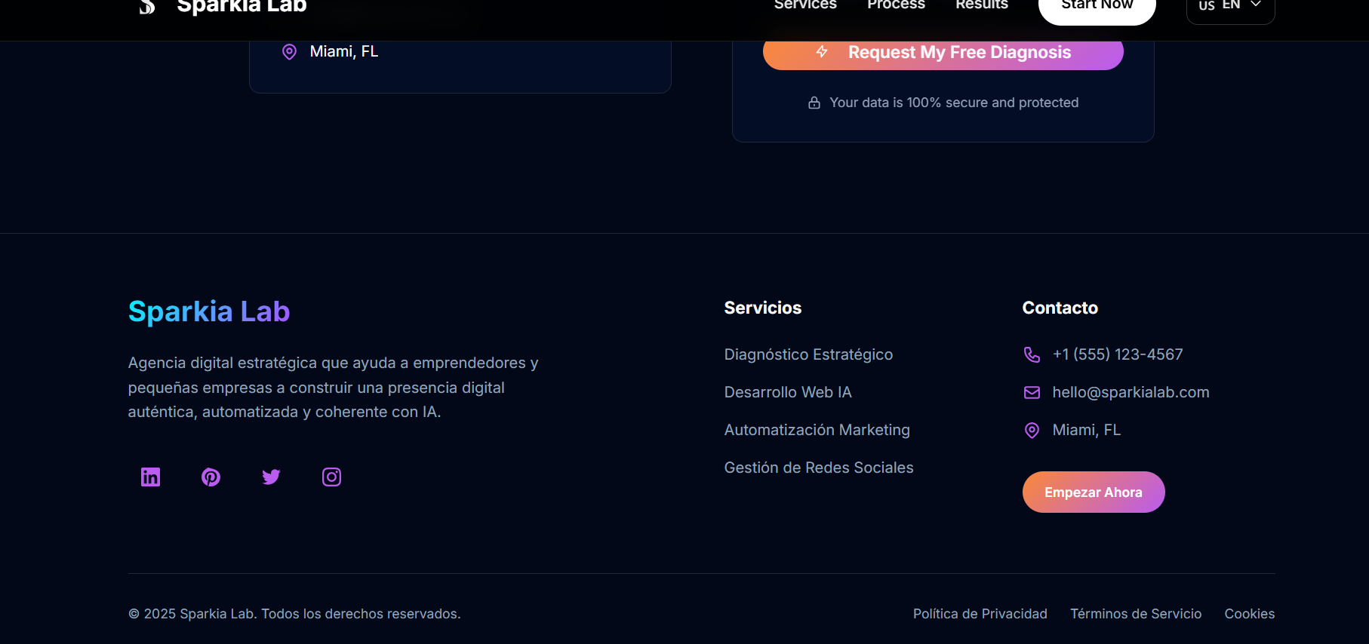

Sparkia Lab
Strategic digital agency that helps entrepreneurs and small businesses build an authentic, automated, and consistent digital presence with AI.
Services
Strategic Diagnosis
AI Web Development
Marketing Automation
Social Media Management
Contact
+1 (555) 123-4567
hello@sparkialab.com
Miami, FL
Get Started Now
© 2025 Sparkia Lab. All rights reserved.
Privacy Policy
Terms of Service
Cookies

